**Gallery X User Guide**

Buttons

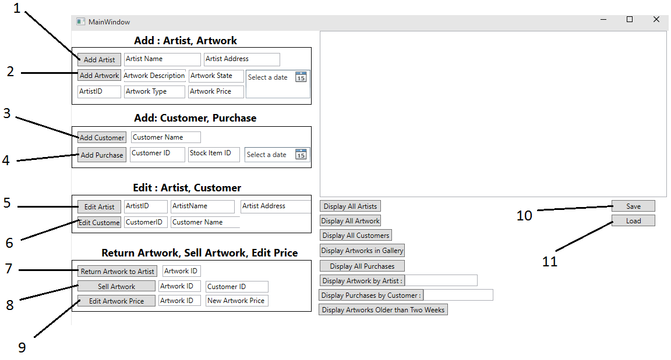

1. “Add Artwork” This button is used to add an Artist to the database using inputs from the two textboxes to its right. It requires both an artist’s name and their address.
2. 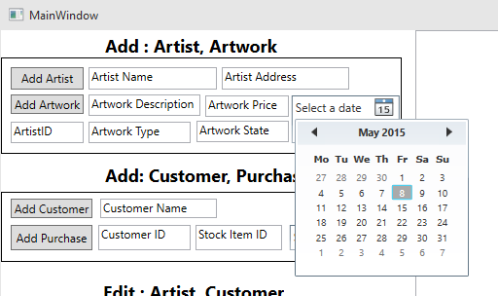“Add Artwork” This button is used to add an artwork to the database using the inputs from the boxes to the right and below. This requires an artwork description, artwork state, date added, artwork type and artwork price and the artist ID of the artist who made the artwork. Dates can be manipulated using the date picker drop down box shown in the image.
3. “Add Customer” This button allows the user to add a customer to the gallery database. This requires a name to be inputted into the textbox to the right.
4. “Add Purchase” This button allows the user to add a purchase record to the database. This requires the customer ID, the ID of the stock purchased and also the date it was purchased.
5. “Edit Artist” This button allows the user to edit the attributes of an artist saved in the database, this requires the ID of the artist being edited, the new artist name and the new artist address.
6. “Edit Customer” This button allows a customer to edit the attributes of a customer saved in the database, this requires the customer ID and the new desired customer name.
7. “Return Artwork to Artist”. This button allows the user to change the details of a piece of artwork to show that it has been returned to the artist. This requires the artwork ID to be inputted.
8. “Sell Artwork” This button allows the user to designate that a piece of artwork has been sold to which artist. This requires the artwork ID and the customer ID.
9. “Edit Artwork Price” This button allows the user to edit the price of a piece of artwork. This requires the artwork ID and the new desired price.
10. “Save”, this button allows the user to save any changes made to the database.
11. “Load” This button allows the user to load the database from the data files, this can be used if the user has made a mistake.

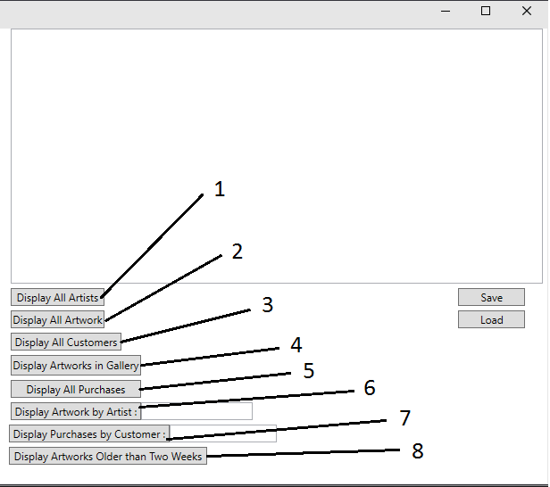

1. “Display all Artists” This button will display all Artists and their stored attributes in the ListBox above.
2. “Display All Artwork” This Button will display all Artworks and their stored attributes in the ListBox above
3. “Display All Customers” This button will display all Customers and their stored attributes in the ListBox above.
4. “Display Artworks in Gallery” This button will display all Artworks that are currently on display in the gallery and their stored attributes in the ListBox above.
5. “Display All Purchases” This button will display all purchases stored in the database and the details of them in the ListBox above.
6. “Display Artwork by Artist” This button will allow the user to display all Artwork that belongs to an artist, this requires the artist name which is inputted into the textbox to the right of the box.
7. “Display Purchases by Customer” This button will allow the user to display all Purchases by a customer, this requires the customer name which is inputted into the textbox to the right of the box.
8. “Display Artworks Older than Two Weeks” This button will allow the user to display all artworks that have been on display in the gallery for longer than two weeks.

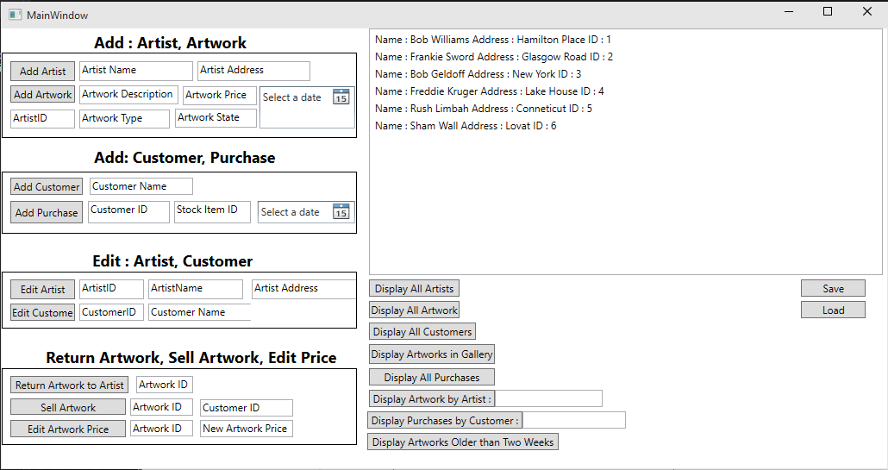

The image above shows an example output when the user presses “Display All Artists”. This method can be used by the user to retrieve the ID of an artist for used in other function.

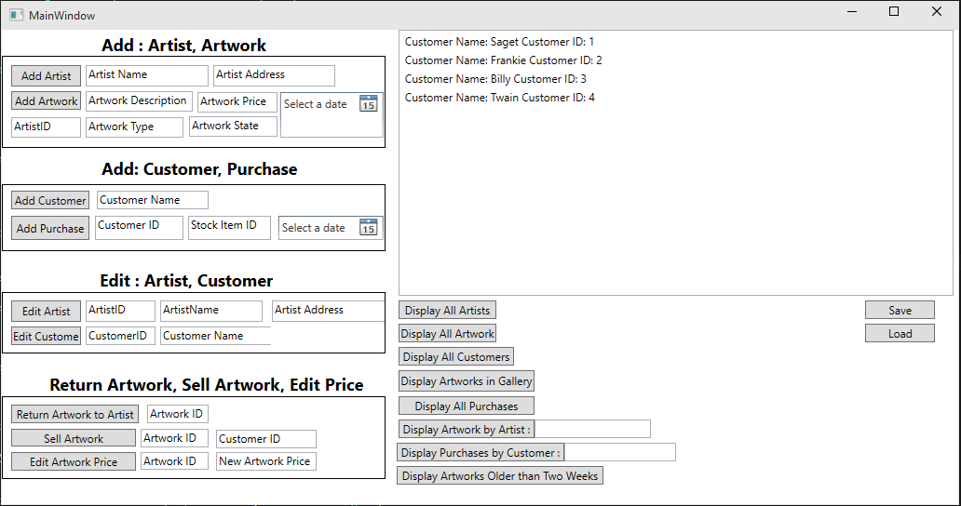

The image above shows another example output however this is the result of the used selecting “Display All Customers” This is also how the user can find the ID of a customer.